CERTIFICATE OF LIABILITY INSURANCE |  |  | DATE (MM/DD/YYYY)
THIS CERTIFICATE IS ISSUED AS A MATTER OF INFORMATION ONLY AND CONFERS NO RIGHTS UPON THE CERTIFICATE HOLDER. THIS CERTIFICATE DOES NOT AFFIRMATIVELY OR NEGATIVELY AMEND, EXTEND OR ALTER THE COVERAGE AFFORDED BY THE POLICIES BELOW. THIS CERTIFICATE OF INSURANCE DOES NOT CONSTITUTE A CONTRACT BETWEEN THE ISSUING INSURER(S), AUTHORIZED REPRESENTATIVE OR PRODUCER, AND THE CERTIFICATE HOLDER.
IMPORTANT: If the certificate holder is an ADDITIONAL INSURED, the policy(ies) must have ADDITIONAL INSURED provisions or be endorsed. If SUBROGATION IS WAIVED, subject to the terms and conditions of the policy, certain policies may require an endorsement. A statement on this certificate does not confer rights to the certificate holder in lieu of such endorsement(s).
PRODUCER | CONTACT NAME:
PRODUCER | PHONE  (A/C, No, Ext): | FAX  (A/C, No):
PRODUCER | E-MAIL  ADDRESS:
PRODUCER | INSURER(S) AFFORDING COVERAGE |  |  | NAIC #
PRODUCER | INSURER A :
INSURED | INSURER B :
INSURED | INSURER C :
INSURED | INSURER D :
INSURED | INSURER E :
INSURED | INSURER F :
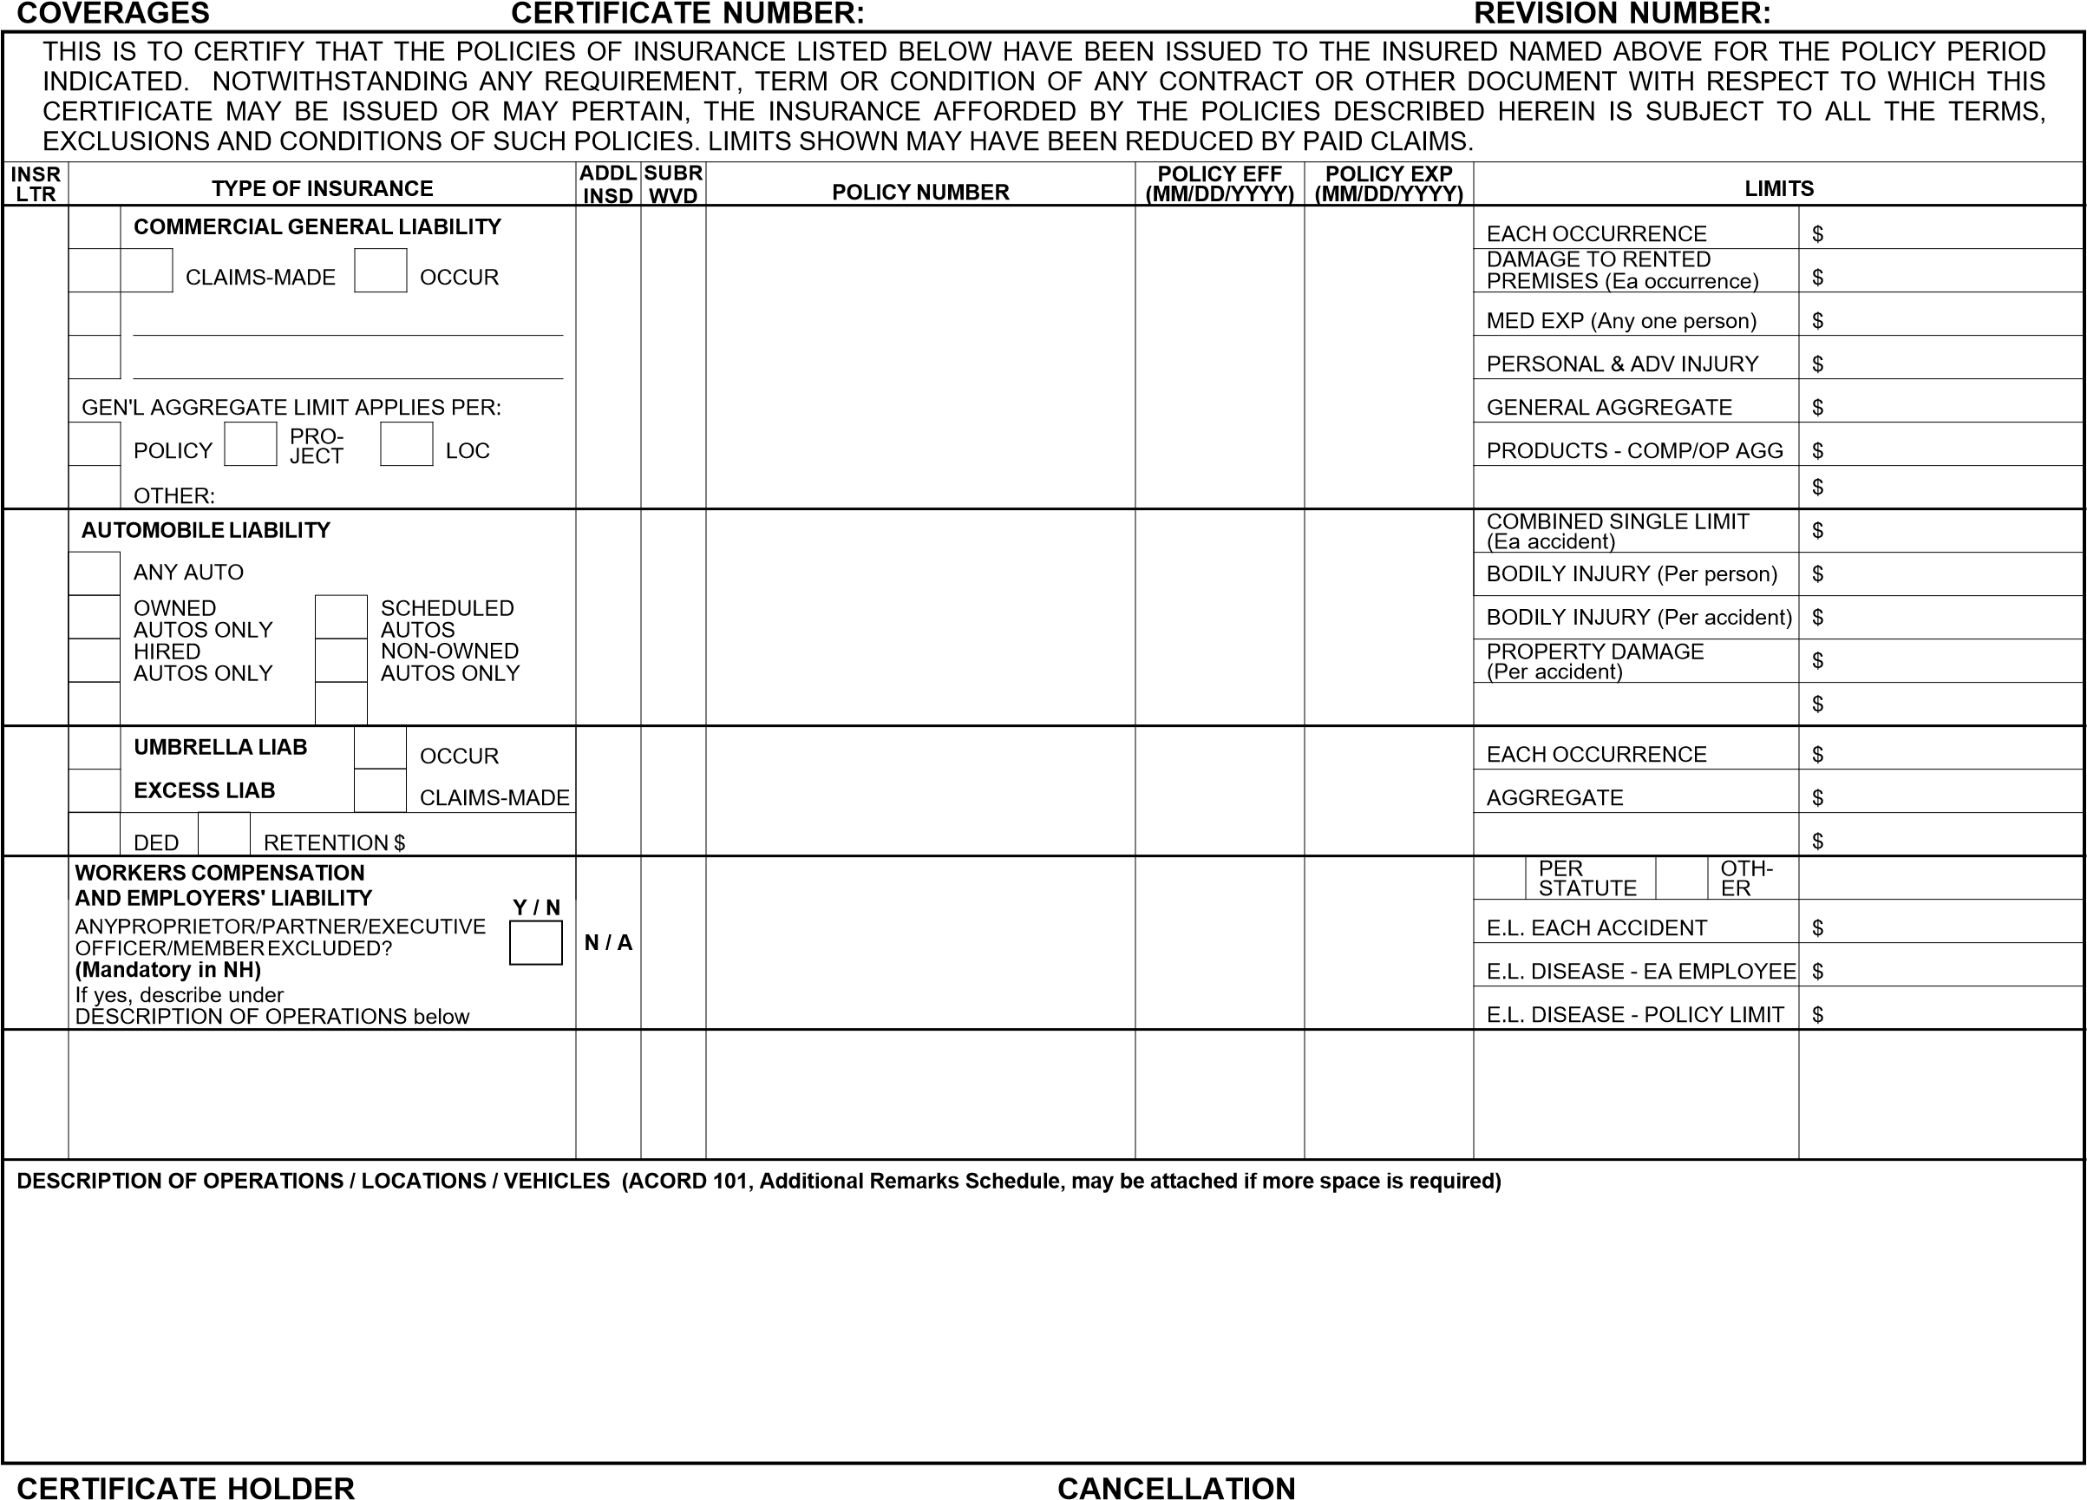
SHOULD ANY OF THE ABOVE DESCRIBED POLICIES BE CANCELLED BEFORE THE EXPIRATION DATE THEREOF, NOTICE WILL BE DELIVERED IN ACCORDANCE WITH THE POLICY PROVISIONS.
AUTHORIZED REPRESENTATIVE
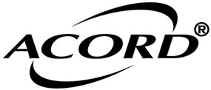
© 1988-2016 ACORD CORPORATION. All rights reserved. ACORD 25 (2016/03) The ACORD name and logo are registered marks of ACORD

